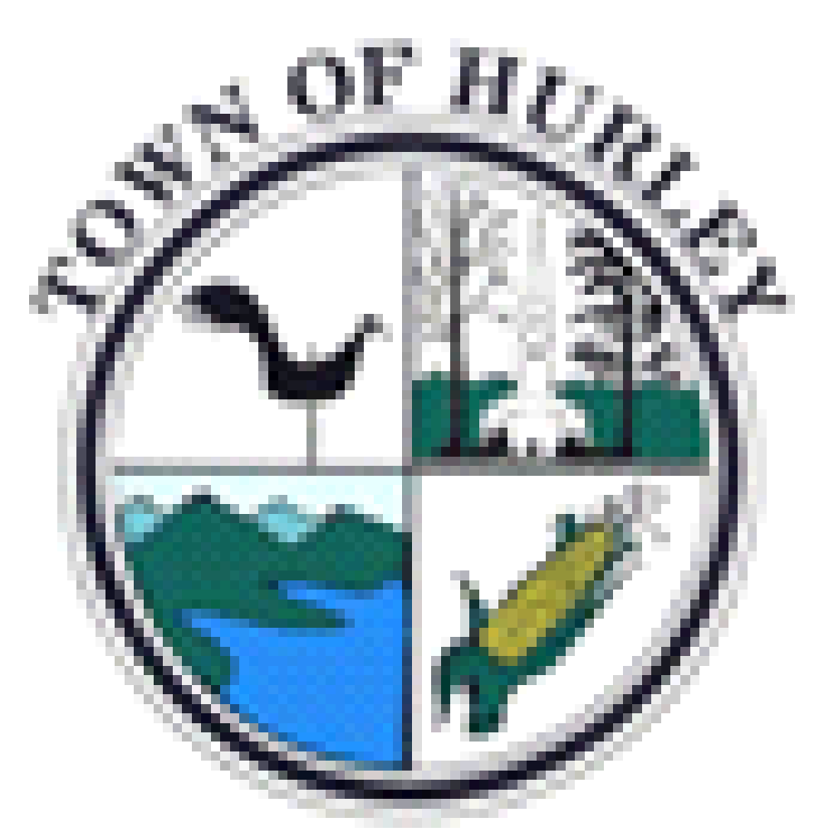

**TOWN OF HURLEY PLANNING BOARD**

**PO BOX 569**

**Hurley, New York 12443**

[planning@townofhurley.org](mailto:planning@townofhurley.org)

**(845)331-7474 Ext. 6**

**NOTICE OF SPECIAL MEETING**

**PLEASE TAKE NOTICE** that, at the call of the Chair, the previously scheduled Special Meeting scheduled for Thursday, August 24, was postponed due to a lack of quorum. The Town of Hurley Planning Board will hold a rescheduled special meeting on Wednesday, August 30, 2023 at 10:30AM at the Town Hall, 10 Wamsley Place, Town of Hurley, County of Ulster, State of New York, for the purpose of considering:

1. **File-2020-#10-Southern Realty Development/John Joseph-AKA-Dunkin’ Donuts-SBL-38.10-7-9-SP**

Location: 1460 & 1462 Rte. 28, West Hurley/B-1 zoning.

The public hearing has closed for this application, and no public comment of any kind will be accepted by the Planning Board at this meeting. .

DATED: August 23, 2023

Maggie Colan, Clerk

Hurley Planning Board

